What is God building in Transylvania
Szabolcs & Julia Becze

Introduction
My name is Szabolcs Becze (Szabi), I was born and live in Odorheiu Secuiesc, which is part of Transylvania, Romania. My wife Julia and I have 3 children. Julia is working as an architect and I studied Computer Science.
Location on Google Maps: https://maps.app.goo.gl/Es8eQokeFD9M9vcW6
10 years ago, I quit my job at Garmin and decided to start my own company (ExarLabs) - not because I was unhappy with my job at Garmin, but I felt that there should be more in my professional life than just working and get paid, it should have a deeper significance and impact than just growing the profits.
Julia was already a believer, but I would describe myself as an agnostic. Nevertheless, seeing Julia’s faith, I decided to start this new company together with God, testing whether He truly cares about the business world.
The first year was really tough - we used up almost all of our savings and God tested my faith (for some reason Julia was never afraid). I started to pray and ask God for guidance, and I remember the first time when I clearly heard His voice inviting me to look for other similar companies which are led by God. This is when I attended the GLS and saw your video. I decided to contact you, but I honestly expected no answer as you looked like unreachable movie stars from a big American production, not like a real company. Surprisingly, Casey responded and asked me if I had read the articles on the website. So I did.
Long story short, I got to know Volkert and attended the first KAW Europe in Holland. I have read the Leadership Guide multiple times and founded a Prayer group for Leaders together with Julia. Together with a friend (Andrew Újvári) whom I talked to you about, we translated this book and we are excited to be organizing the first KAW Event in Budapest.
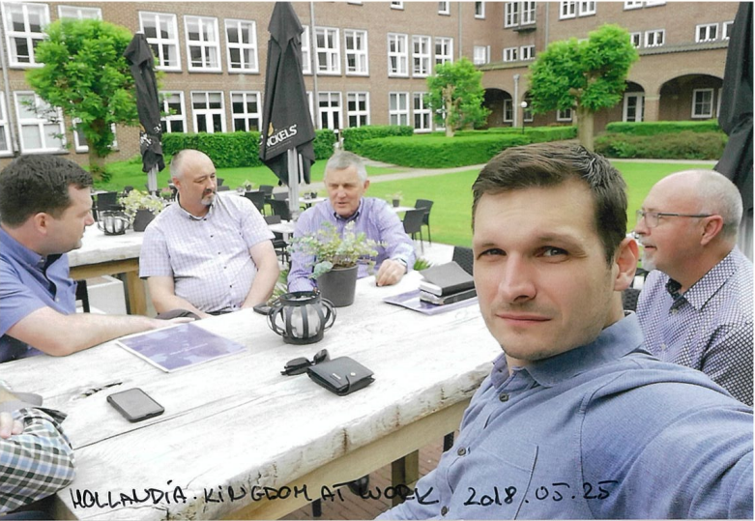
1. Picture: First KAW Europe

My company has since grown stronger - we are now a team of 12, and we have become a Kingdom Company. Inspired by BBH, we created a board that leads together with God, an ESOP-like share structure, and many more.
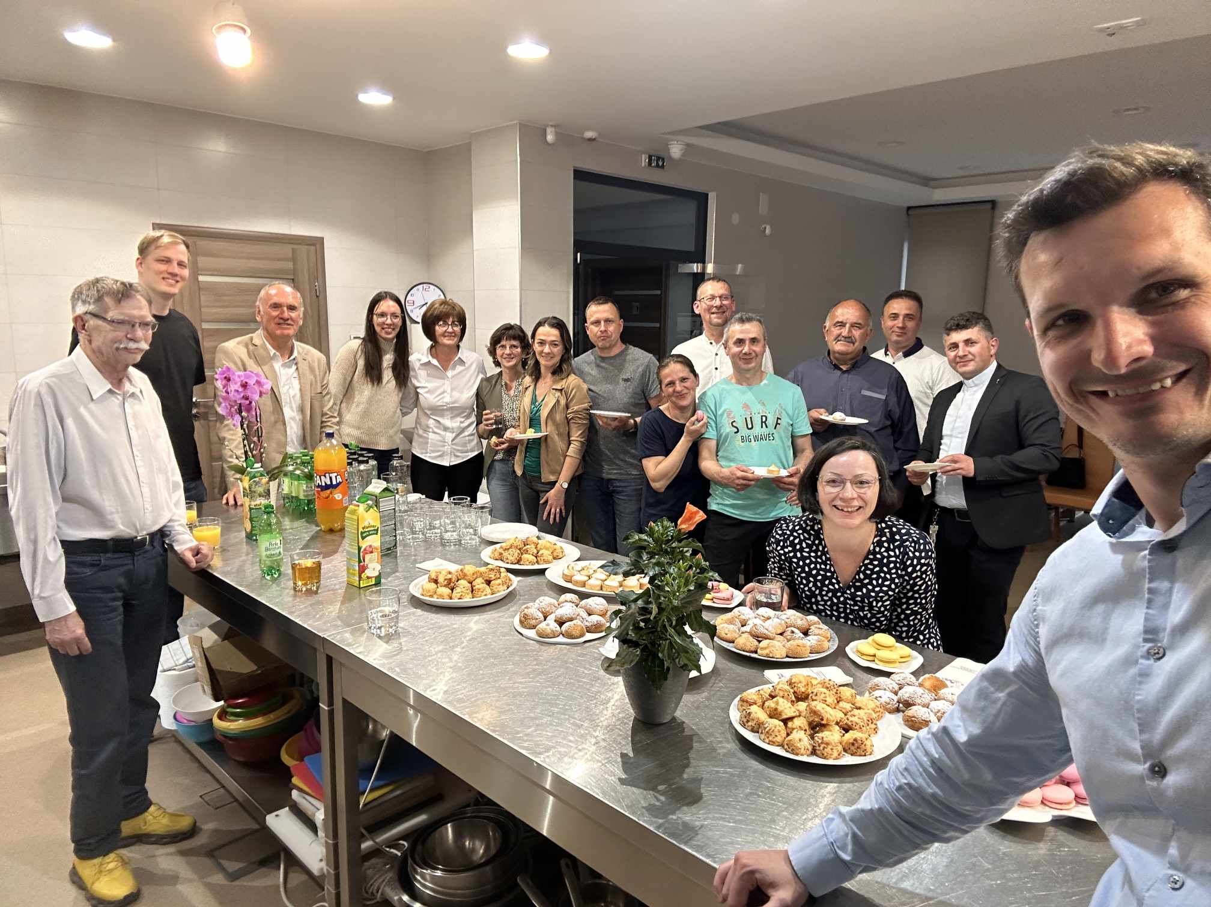
2. Picture:Prayer group for Leaders in June 2025
The reason why we are reaching out to you is because of a calling that we received in a prophecy. We are also asking for your partnership, both in prayer and financially - we are short $36,000 to be able to move forward this year.

The Prophecy
Five years ago, we received a prophecy regarding our family’s calling. We were told to look for a house that we would use for God’s service.
We received fairly specific instructions about the house:
- The house must be able to host guests.
- It should be in the center, yet hidden.
- It must have a well (we still do not know why).
- We should begin searching, and when we see it, we will recognize it.

This house will become a command center for our city and a place where we will host people sent by God - leaders who are seeking God and who want to learn.

How We Began Searching
Juli and I started walking through the city and looked at several properties. Around the fifth house, we experienced a striking confirmation - it was a perfect match.
On a small plot there were two separate houses. We were told that the second house had been built for the parents of the owners, but because it is located on the side of a hill, they later realized the parents would be too old to walk up the steep slope.
It has a well, and it is truly not visible from the street, yet it is only about a five-minute walk from the city center.
When we discovered this, we contacted the owner. However, it was a very unusual situation because we did not have the money to buy the house. It became clear rather quickly that we could not afford it.
Location of this house on Google StreetView : https://maps.app.goo.gl/vuPidpYGwWzf3eXc7
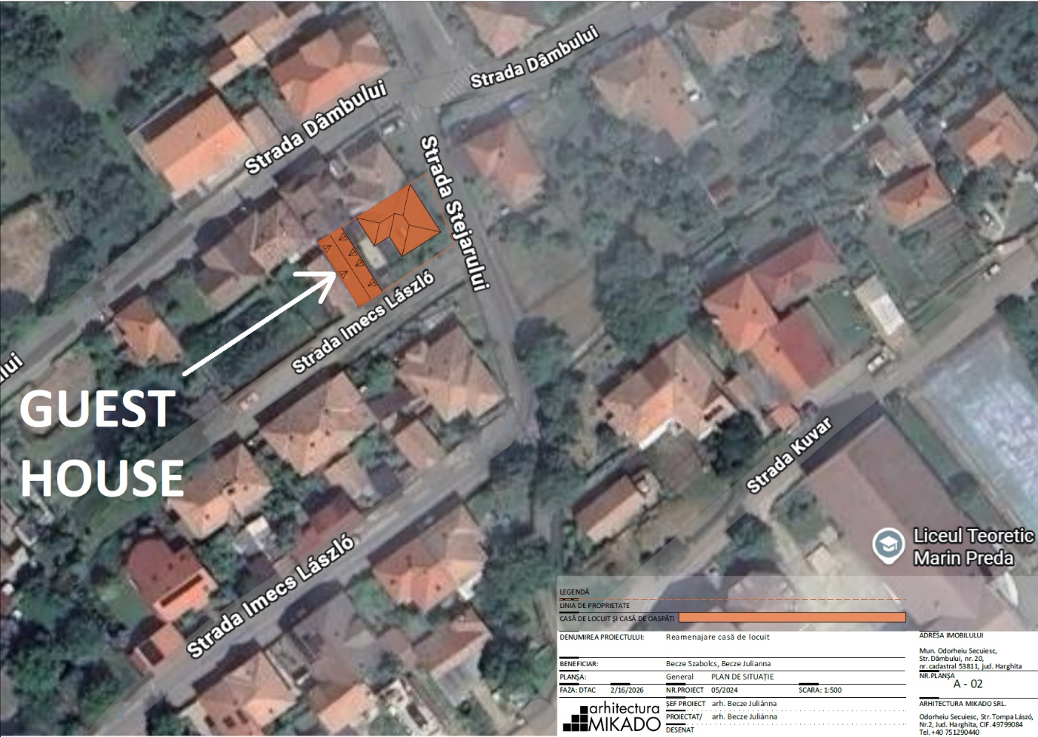
3. Picture: The house positioning on map
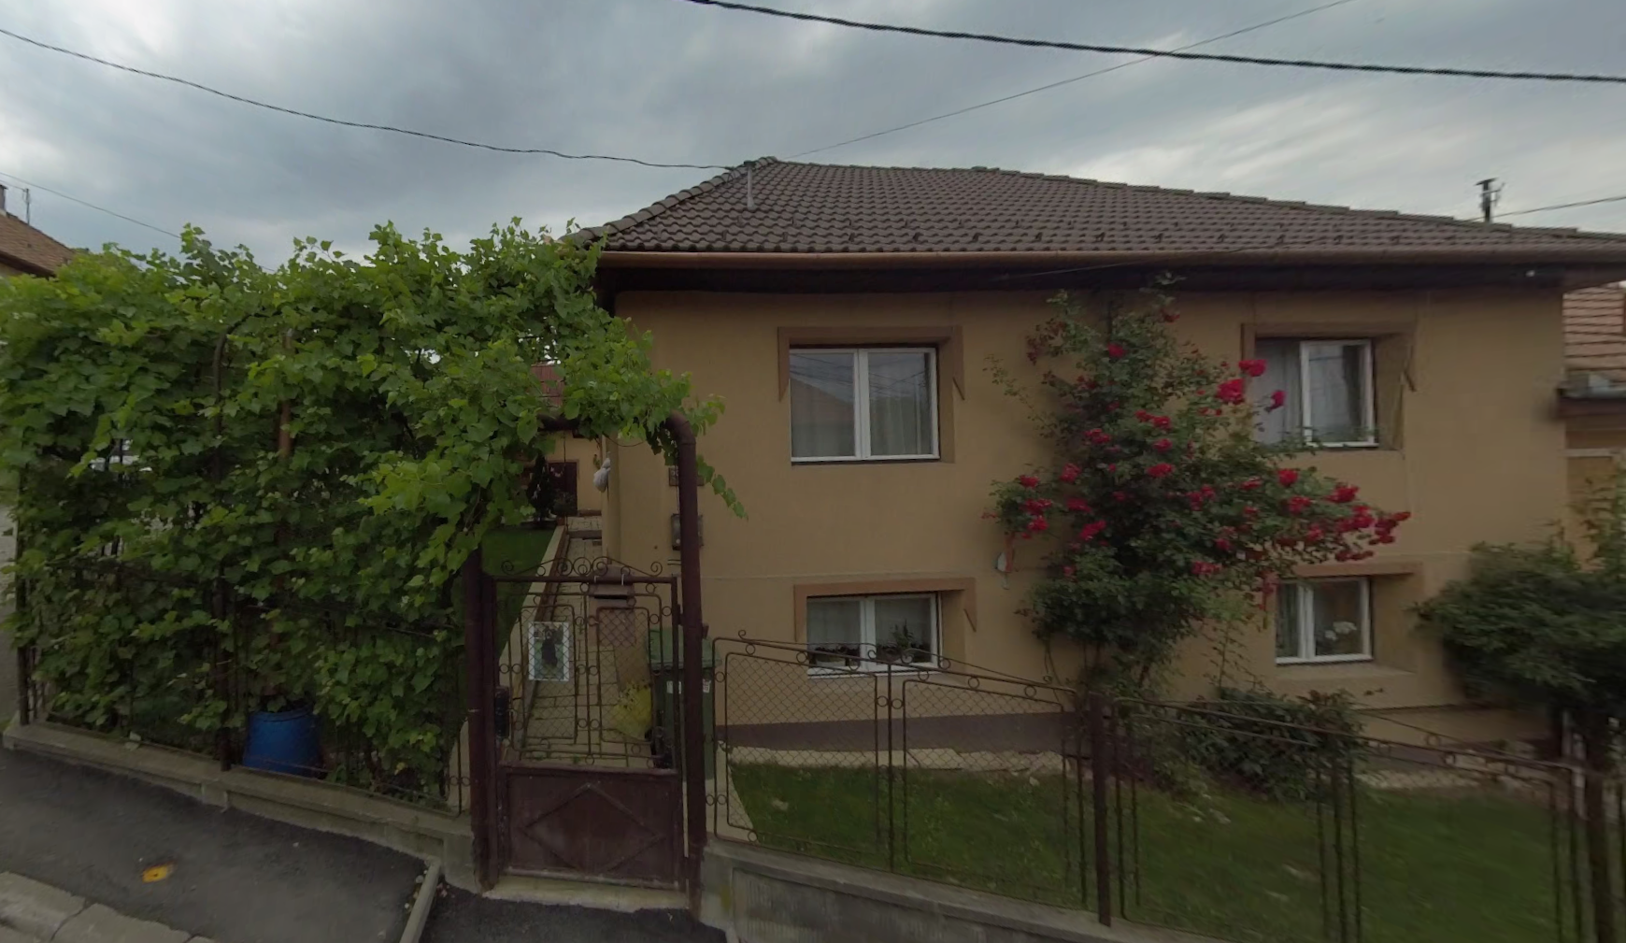
4. Picture: The house front door

Unfortunately, we had to let it go. Instead, we purchased a smaller apartment in the city center and temporarily released the house. However, since the prophecy was still valid, we regularly went there to pray and dedicate the house to God’s project.
To our surprise, the years passed and the house could not be sold at all. We spoke several times with the owner, until eventually we decided to buy it in three installments over three years.
Although humanly speaking we could not generate the money within three years, God told us that we no longer had time - we should move forward with the deal, and He would provide the money.
The original plan was:
YEAR | EUR | USD | Notes
2025 | €30,000 | $35,602 | Paid
2026 | €40,000 | $47,470
2027 | €20,000 | $23,735
2028 | €110,000 | $130,541
Total | €200,000 | $237,348

The Adoption
Alongside the house, we also have another calling: we would like to adopt a child. (We currently have three children of our own.) We would like to start the process already this year, but our current apartment is 60 square meters and fully occupied. Unfortunately, we cannot accommodate one more person.
The adoption process in Romania takes 1-2 years from the moment it begins. This means that if we cannot move into the house by 2027, we will have to delay the start of the process as well.
Our desire is therefore to move into our bigger house by 2027 - both to begin the ministry there and to have the space needed to start the adoption.

Our Plan and Where We Need Help
The overall payment plan looks like this:
YEAR | EUR | USD | Notes
2025 | €30,000 | $35,602 | Paid
2026 | €40,000 + €20,000 | $71,205 | We can gather $35,000
2027 | €110,000 | $130,541 | OK
Total | €200,000 | $237,348

We need to pay $71,205 by the end of June 2026. Realistically, we can gather $35,000 on our own - which means we are short $36,000.
In 2027 we can pay the remaining $130,541 because by then we will have sold our current home.
If we can cover the $36,000 gap this year, we can move in by 2027 and start both the ministry and the adoption process.

What This Means for KAW
According to the prophecy, this house should become a command center in our city and perhaps in our county. I already see that the principles and the way our company is led are spreading here, and my calling is to continue this. Most likely, God will send us leaders who will stay with us for a few days to discuss the Kingdom of God.
What we will be teaching here follows essentially the same principles that KAW shares, so this house could also act as a mission center for KAW in this region. I believe there is other common ground we could explore together.
I also host a podcast where quite often I speak about the Kingdom Principles, for instance in this episode: 10. Elekes István: Hit és vezetés - keresztény szemlélet a munkaban (YouTube): https://www.youtube.com/watch?v=wVLydj4eUFg
I shared this calling with Wieslaw, and he encouraged me to reach out directly - not just to ask for help, but to invite you to be part of what God is building in this region.

